Assignment 3
Troy Toth
Objective:
The objective of this assignment is to explore the ability to predict data over time. This time-series forecasting plays a vital role in almost every business and industry from weather prediction to retail sales forecasting. This ability to predict trends in data over time can make or break a business. If they can stay ahead of the trends, then they can predict future product sales or financial markets.
Methodology:
The project is split into 5 main parts:
- Baseline model
- Dense model
- LSTM (64 units)
- CNN and LSTM (64 units)
- Deep LSTM (128 units)
For each step, the MAE was compared to test what performed the best.
Experiment and Results:
Step | Test MAE Score
Baseline model | 4.17
Dense model | 3.30
LSTM (64 units) | 2.50
CNN and LSTM (64 units) | 2.28
Deep LSTM (128 units) | 2.15

Dense Model Plot:
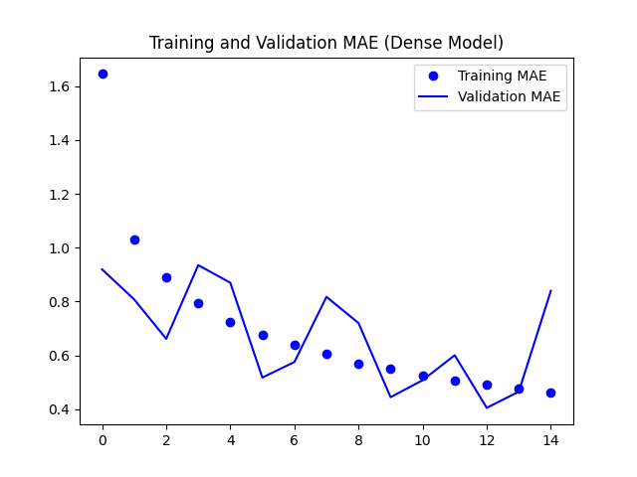
LSTM Plot:
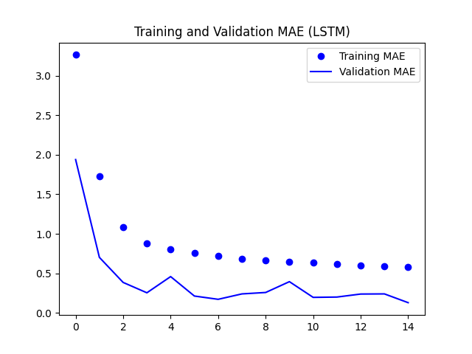
Deep LSTM Plot:
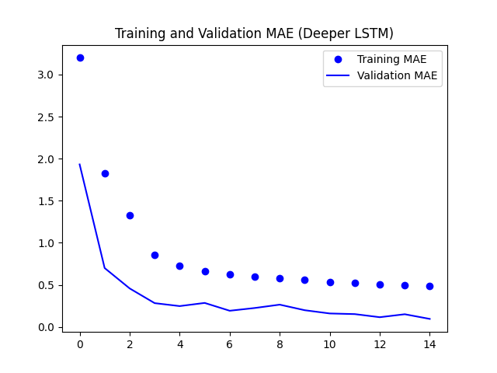
Conclusion:
This project explored the task of forecasting future temperature readings using a dataset that recorded the temperature every ten minutes. The first created model, the baseline, achieved an MAE of 4.17 giving me a reference for testing the more advanced models. I then used some more complex neural network models to try and improve the performance of the model. The next model created was simple more dense model that gave an MAE of 3.30 showing a slight improvement compared to the first. Introducing the RNN (LSTM) greatly improved the model’s performance towards the time-series data and resulted in a MAE of 2.50. The CNN and LSTM model plus the deeper stacked LSTM improved the models even further although not by a huge factor. Overall, the best performing model was the deeper stacked LSTM giving a MAE of 2.15. These results show just how essential temporal modeling is for accurate weather prediction.

